Rosin the Bow
Electr-Irish, Loud, Proud, and not always Trad
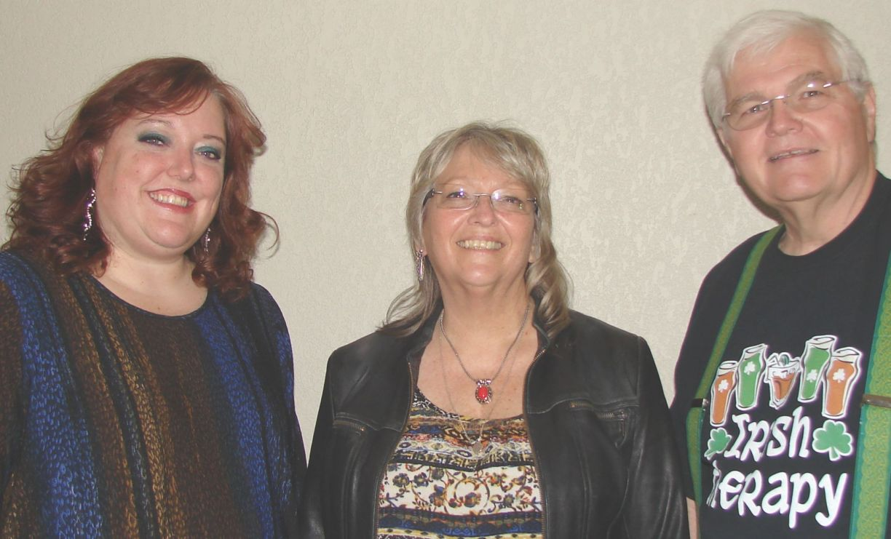
www.facebook.com/rosinthebowco 720-254-6011 email: rosinthebow2009@hotmail.com www.rosinthebow.com
Originally from Connecticut, a region known for its Irish traditions, Grant and Marta Day moved to Colorado, met up with Kris Saprano and continued Rosin the Bow. With Marta on fiddle, Grant on guitar and banjo, and Kris on bass guitar, they are getting a reputation as talented performers in the Front Range area of Denver. Rosin the Bow's music ranges from Irish rock covers of Drop Kick Murphy's and Flogging Molly's, to original arrangements like our punk version of Drunkin Failure and our mystical version of the traditional Spancill Hill. We always add a toast or two, shenanigans and malarkey, and banjo jokes.
Rosin the Bow were featured performers at Clancy's 2016 and 2017 St. Patrick's Day hooley and are regulars on the weekends and at sessions. We have also played at the Grandview in Olde Town Arvada and the Westminster Brew Pub. Rosin the Bow was the opening act at Clancy’s First Annual Irish Festival in August 2017.
Grant Day is an award winning banjo player. Marta Day writes, arranges, teaches violin and also plays with the Broomfield Symphony. Kris Saprano is a music team leader and solo vocalist at King of Kings Lutheran Church.

I've traveled this world all over ad now to another I go
I know that good quarters are waiting to welcome old Rosin the Bow

